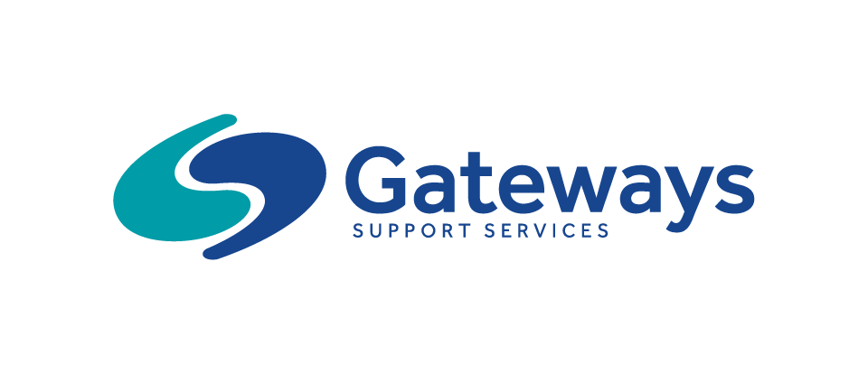

Western Melbourne
Gateway to School Program 2021 – Registration Form
Send to: Bernadette.walker@gateways.com.au
Child’s Name : |  | Date Of Birth :
Gender:  Male Female | Is your child Aboriginal or Torres Strait Islander?  Yes No
Address:

School your child will attend in 2021 :

Please state your child’s diagnosis and/or additional needs:

Is your child receiving Early Intervention Support?  Yes No | If Yes, please state the name of the agency and the name of the Key Worker:
Does your child have an NDIS package?  Yes No | If Yes, please provide the following details;  NDIS Number _________________________________  Start Date of Current Plan _______________________  End Date of Current Plan ________________________
If No, does your child have HCWA funding?  Yes No | If Yes, please attach a copy of your letter of introduction to this registration form.  Attached
Parent/Legal Guardian Information 1 (Primary Contact) | Parent/Legal Guardian Information 2
Name: | Name:
Relationship to Child: | Relationship to Child:
Address (if different to the child): | Address (if different to the child):
Email Address: | Email Address:
Home Telephone: | Home Telephone:
Mobile Telephone: | Mobile Telephone:
First Language if not English: | First Language if not English:

Please complete over the page:
Did your child receive KIS funding at Kindergarten in 2020? | Yes | No
Does your child consistently show behaviours of concern? | Yes | No
If Yes, please provide more information:

Does your child have well developed communication skills? – i.e. they can make their needs known. | Yes | No
Comments:

Does your child have any mobility issues that we need to be aware of? | Yes | No
Comments:

Does your child have asthma? | Yes | No
If Yes – Please attach Asthma Plan

Does your child have any allergies? | Yes | No
If Yes, please provide more information:

From your perspective, what skills does your child need to work on in relation to school readiness?

Please provide further information to any of the areas above, or any other information that you feel the program staff need to be aware of to support your child’s attendance in the Gateway to School Group.
________________________________________________________________________________________________________________________________________________________________________________________________________________________________________________________________________________________________________________________________________________________________

Do you give your permission for the Gateway to School Program staff to make contact with your child’s Key Worker/therapists to gain more information about their developmental needs?
Yes No
_____________________________________________ ____________________
Signature of Parent/Legal Guardian Date

